Whole project report on the lifecycle and scheduling issues

WEBSCRP

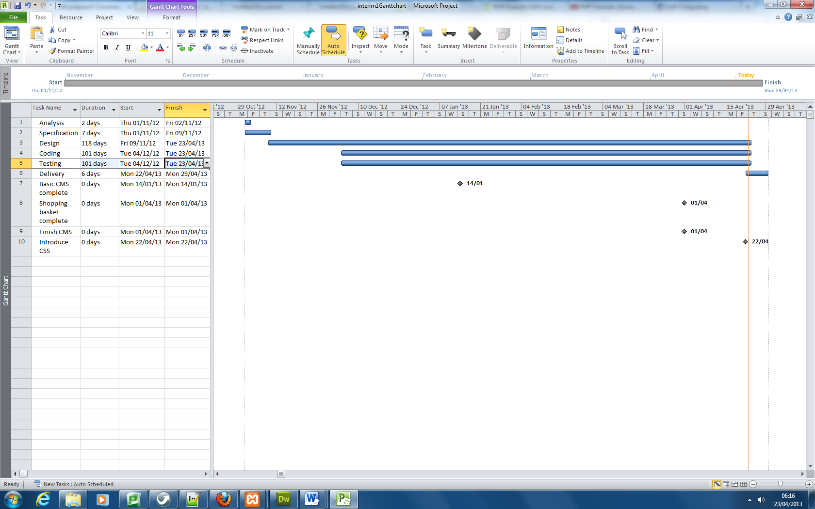Student Number: 617162

*Gantt chart of final effort/dates including new milestones*

I found this unit the most challenging because I had to learn multiple web programming languages before I could actually use them. I’ve learnt that the order in which tasks are done are never done step after step as the cascade waterfall shows. I found that at some times, parts of code testing are done first before they can potentially be designed until they can finally be implemented. It felt that they were all done in parallel at the same time or at random which I found interesting as it conflicted with Royces model.

The scheduling was originally good at the start however I noticed that progress was beginning to be sluggish as I found problems with code syntax errors harder to fix as the amount of coding grew in my product. I also then found myself spending more time fixing these errors rather than actually developing the product itself. There were some instances where I spent over an hour trying to solve some problem only to find the answer was the fact I had forgot to put a space between a double and single quote. I state this because it really improved my analytical skills of being able to find variables that were not rendering.

I originally stated in the previous interim that my progress was increasing exponentially because as I understood the programming language more, I could utilise this more effectively. I was wrong because I found myself struggling with implementing PHP with AJAX and Javascript to the point I was unable to do it. This was very frustrating at first because I admit my programming skills aren’t top class however I find the fun is all in the learning phase.

A surprise that came about was the continuous amount of work required for the whole product (that was constantly being discovered). It caught me off guard because I had a relatively good idea of how the minimal functionalities were going to be implemented but even these were not easy to accomplish. I found that as time went on, the possibility of completing my milestones were less likely which a worry was for me so I decided to dedicate more time into the product. It isn’t a simple process of “putting more time into the product” because I have other lecturers who have set me other coursework with deadlines which require my attention and I hate giving the majority of my time to this product because my other coursework could potentially suffer.

One major mistake was going home for the first week of the Easter break. It was a difficult situation because my parents had missed me and my mother especially wanted me to visit home to see her before she travelled abroad for a funeral. I could have tried to do work at home but I’ve always found it difficult to study there because of the noise and lack of space in the house which is why I spent most of my time in University Library- a quiet learning environment.

I now realize I should have stay in Portsmouth to focus much more on university work as all the deadlines are approaching soon along with exams which equals lots and lots of pressure. Fascinating to find that when I finally returned to Portsmouth, I was extremely motivated because I knew I had missed a whole weeks worth of time that could have potentially been used productively to do work. There were moments where I couldn’t sleep because I knew I hadn’t done enough work for this product to pass the unit so I stayed up late into the late to finished certain milestones planned on the Gantt chart.

With more than a week left until the demonstration, I planned to stay in the library for at least ten hours per day with another student in the WEBSCRP unit to help keep moral high for each other by assisting one another. Another surprise that came about was the SPEC office phoning me to inform me of a placement interview a few days before demonstration deadline – OUCH! It was a dilemma whether to book the interview or reject however I decided to stick strong and carry on with the interview which I took a day off in order to prepare for.

I think there were health issues involved that surprised me because I didn’t expect coursework to affect me so seriously. With two days before the deadline, I stayed in the library for the whole night to continuously code where I felt mentally and physically drained in the daytime. Definitely something not to try in the future if it can be avoided! Then again, my rationale behind it was that I wouldn’t have been able to sleep anyway if I had gone home because of the stress.

In the end, I am impressed with what I have achieved as I have overcome many programming difficulties with much determination. I admit the product isn’t perfect where the admin is missing CSS and the public page’s CSS has many errors. My reason for that is because I mentioned in the previous interim “Form follows Functionality” which I still believe because although the product isn’t finished with CSS (the form), it has many functionalities which is where the real learning lies and I am pleased with the many skills I have gained from this unit.

If I were to do this again, I feel I’d approach the design and development in a very different way since I’m more confident with web programming now. Before this year, I only had knowledge of HTML however this unit has opened many opportunities for me for future projects. I have already discussed with friends about a programming our own online forum using login accounts which would be a big step up from this WEBCRP coursework. We agreed it would be more challenging however it would be more exciting to produce and the rewards would be greater.